BUSINESS REPORT:
MACHINE LEARNING PROJECT – Easy Visa

Prepared By: Subhadip Mitra

PGP – DSBA.O. MAY 2025

Contents-
List of Tables----------------------------------------------------------------------- 3
List of Figures-----------------------------------------------------------------------4
1.Data background and contents -------------------------------------------- 7
2.Objective------------------------------------------------------------------------ 7
3.Data Description--------------------------------------------------------------- 8
4.Univariate Analysis------------------------------------------------------------ 11
5.Bivariate Analysis-------------------------------------------------------------- 24
6. EDA Questions----------------------------------------------------------------- 39
7. Data Pre-processing--------------------------------------------------------- 41
8. Building Logistic regression Model-------------------------------------- 43
9.Building Decision tree model---------------------------------------------- 60
10.Model Performance Comparison and Final Model Selection----- 73
11.Actionable Insights & Recommendations------------------------------73

List of Tables-
Table-1- Column names and data type
Table-2- Correlation Matrix
Table-3- Missing Value check
Table-4- Shape of Test and Training Test
Table-5- Logistic Regression Model
Table-6- Training performance
Table-7- Checking Multicollinearity
Table-8- Logistic Regression Model after treatment of Multicollinearity
Table-9- Training performance
Table-10- Test performance
Table-11- Converting Coefficients to odds
Table-12- Training performance
Table-13- Training performance Threshold(0.37)
Table-14- Test performance Threshold(0.37)
Table-15- Training performance Threshold(0.43)
Table-16- Test performance Threshold(0.43)
Table-17- Training performance comparison
Table-18- Test performance comparison
Table-19- Shape of Test and Training Test
Table-20- Training performance
Table-21- Test performance
Table-22- Training performance(pre-pruned)
Table-23- Test performance(pre-pruned)
Table-24- Training performance(post-pruned)
Table-25- Test performance(post-pruned)
Table-26- Training performance comparison
Table-27- Test performance comparison
List of Figures-
Fig-1- Bar Chart- Number of adults
Fig-2-Bar Chart- Number of Children
Fig-3-Bar Chart- Number of weekend nights
Fig-4-Bar Chart- Number of weeknights
Fig-5-Pie Chart- Type of meal plan
Fig-6-Pie Chart- Required car parking space
Fig-7-Bar Chart- Room types reserved
Fig-8-Histogram n Boxplot- Lead time
Fig-9-Bar Chart- Arrival month
Fig-10-Bar Chart- Market segment type
Fig-11-Histogram n Boxplot- No of previous cancellations
Fig-12-Histogram n Boxplot- No of previous bookings not cancelled
Fig-13- Average price per room
Fig-14-Bar Chart- No of special requests
Fig-15-Pie Chart- Booking status
Fig-16- Heatmap-Correlation
Fig-17- Stacked Bar Chart- No of special requests
Fig-18- Boxplot- Average price per room by Market segment
Fig-19- Stacked Bar Chart- booking status and number of special requests
Fig-20- Boxplot- Average price per room by number of special
Fig-21-Histogram n Boxplot- Average price of rooms and booking status
Fig-22-Histogram n Boxplot- Lead time and booking status
Fig-23- Stacked Bar Chart- Total family Members and Booking status
Fig-24- Stacked Bar Chart- Total stay days and Booking status
Fig-25- Line Chart- Rooms prices across various months
Fig-26- Stacked Bar Chart- Total stay days and Booking status
Fig-27- Line Chart- Guest arrival by month
Fig-28- Stacked Bar Chart- Arrival month & Booking Status
Fig-29- Box Plots- Outlier check
Fig-30- Confusion- Test Set
Fig-31- Confusion- Training Set
Fig-32- ROC-AUC- Training Set
Fig-33- Confusion- Training Set Threshold(0.37)
Fig-34- ROC-AUC- Test Set
Fig-35- Confusion- Test Set Threshold(0.37)
Fig-36- Confusion- Precision-Recall curve
Fig-37- Confusion- Training Set Threshold(0.43)
Fig-38- Confusion- Test Set Threshold(0.43)
Fig-39- Confusion matrix- Training set
Fig-40- Confusion matrix- Test Set
Fig-41- Feature Importance
Fig-42- Confusion matrix- Training Set(Pre-Pruning)
Fig-43- Confusion matrix- Test Set(Pre-Pruning)
Fig-44- Decision Tree(Pre-Pruning)
Fig-45- Feature Importance
Fig-46- Total Impurity vs effective alpha for training set
Fig-47- Alpha vs number of nodes & alpha vs number of depth
Fig-48- F1 Score vs alpha for training and testing sets
Fig-49- Confusion matrix- Training set
Fig-50- Confusion matrix- Test set
Fig-51- Decision Tree(Post-Pruning)
Fig-52- Feature Importance

1. Context:

Business communities in the United States are facing high demand for human resources, but one of the constant challenges is identifying and attracting the right talent, which is perhaps the most important element in remaining competitive. Companies in the United States look for hard-working, talented, and qualified individuals both locally as well as abroad.

The Immigration and Nationality Act (INA) of the US permits foreign workers to come to the United States to work on either a temporary or permanent basis. The act also protects US workers against adverse impacts on their wages or working conditions by ensuring US employers' compliance with statutory requirements when they hire foreign workers to fill workforce shortages. The immigration programs are administered by the Office of Foreign Labour Certification (OFLC).

OFLC processes job certification applications for employers seeking to bring foreign workers into the United States and grants certifications in those cases where employers can demonstrate that there are not sufficient US workers available to perform the work at wages that meet or exceed the wage paid for the occupation in the area of intended employment.

2.Objective:
In FY 2016, the OFLC processed 775,979 employer applications for 1,699,957 positions for temporary and permanent labour certifications. This was a nine percent increase in the overall number of processed applications from the previous year. The process of reviewing every case is becoming a tedious task as the number of applicants is increasing every year.

The increasing number of applicants every year calls for a Machine Learning based solution that can help in shortlisting the candidates having a higher chance of VISA approval. OFLC has hired the firm EasyVisa for data-driven solutions. You, as a data scientist at EasyVisa, have to analyze the data provided and, with the help of a classification model:

Facilitate the process of visa approvals.
Recommend a suitable profile for the applicants for whom the visa should be certified or denied based on the drivers that significantly influence the case status.

3.Data Description:
The data contains the different attributes of the employee and the employer. The detailed data dictionary is given below.

case_id: ID of each visa application
continent: Information of continent the employee
education_of_employee: Information of education of the employee
has_job_experience: Does the employee have any job experience? Y= Yes; N = No
requires_job_training: Does the employee require any job training? Y = Yes; N = No
no_of_employees: Number of employees in the employer's company
yr_of_estab: Year in which the employer's company was established
region_of_employment: Information of foreign worker's intended region of employment in the US.
prevailing_wage: Average wage paid to similarly employed workers in a specific occupation in the area of intended employment. The purpose of the prevailing wage is to ensure that the foreign worker is not underpaid compared to other workers offering the same or similar service in the same area of employment.
unit_of_wage: Unit of prevailing wage. Values include Hourly, Weekly, Monthly, and Yearly.
full_time_position: Is the position of work full-time? Y = Full-Time Position; N = Part-Time Position
case_status: Flag indicating if the Visa was certified or denied

Data Type:
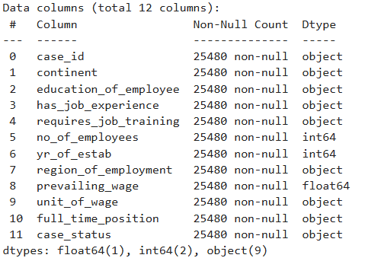
Table-1- Column names and data type

Missing data:
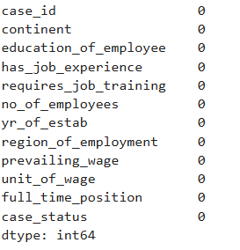
The Statistical summary of the data:
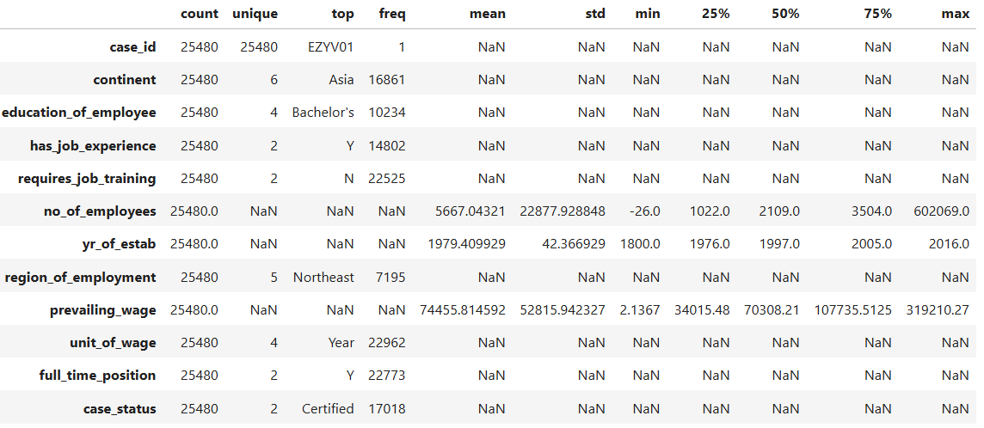
Table-2- Correlation Matrix

Observations
- There are 25480 rows and 12 columns in the dataset.
- There are no null values in dataset.
- There are no duplicate in dataset.
- No_of_employees, yr_of_estab and prevailing_wage is of numeric type while rest columns are object in nature.
- No_of_employees have negative value in them, we will have to investigate it.
- Most people don’t require Job training. (22525 out of 25480)
- More than half of the people in the data has job experience.(14802)
- All the companies in the data were established between 1800 and 2016.
- There 4 types of education of employees, most of them have bachelor’s degree.
- There are 6 continent and most of the application comes from Asia(16861).
- 22773 workers have a full-time job.
- There are 5 unique values on region of employment. The most requested region is Northeast with 7195.
- prevailing_wage has average of 74456. But there’s big difference in Min value(2.1367) and Max value(319210.27) which we will need to check.

4.Univariate Analysis:

• Exploring individual variables (both categorical and numerical), highlighting any findings or outliers in the data.

Continent Uni-Analysis :

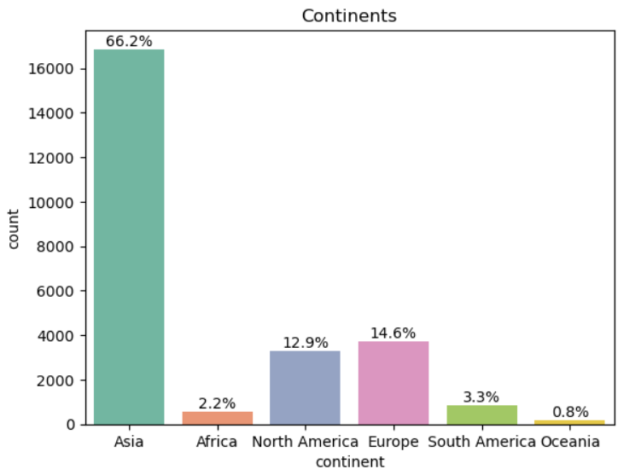

- Most of the worker comes from Asia (66.2%).
- Followed by Europe (14.6%) and North America(12.9%).

Education of employee Uni-Analysis :

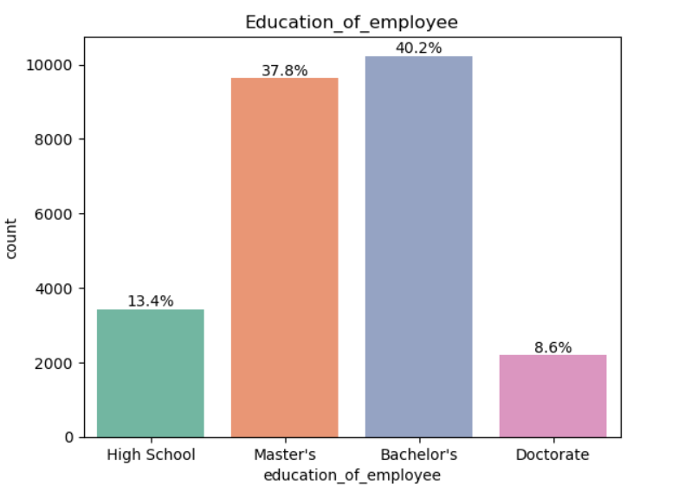

- Most of the workers have bachelor’s degree (40.2%).
- Followed by Master’s (37.8) and High school degree(13.4%).
- Very few people have doctorate(8.6%).

Job Experience Uni-Analysis :
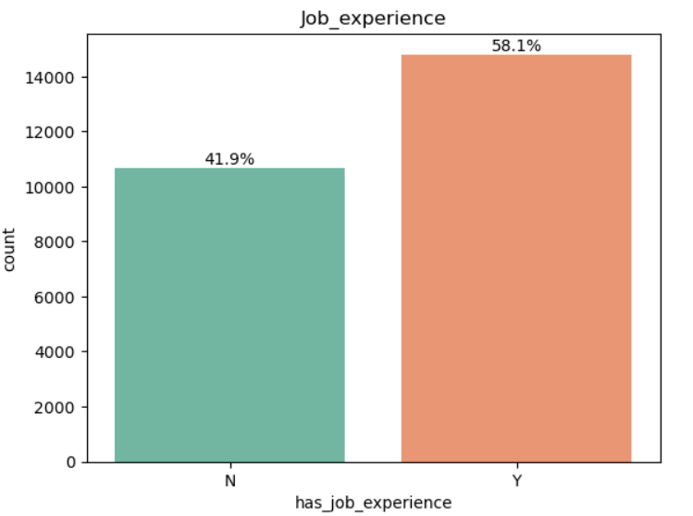

- Little more than half of the people(58.1%) has job experience.

Job Training requirement Uni-Analysis :
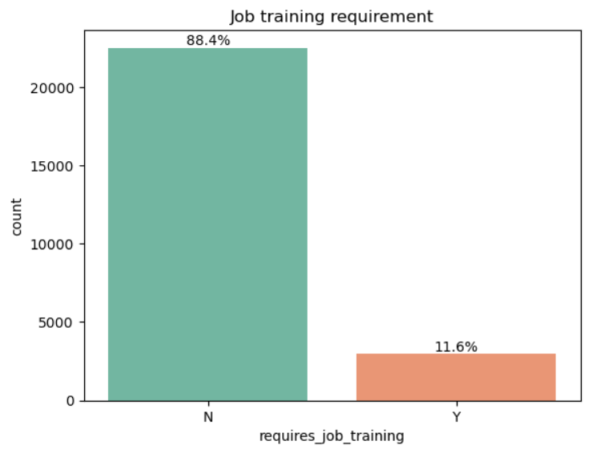

- Most of the workers (88.4%) don’t requires any Job training.

Number of employees Uni-Analysis :

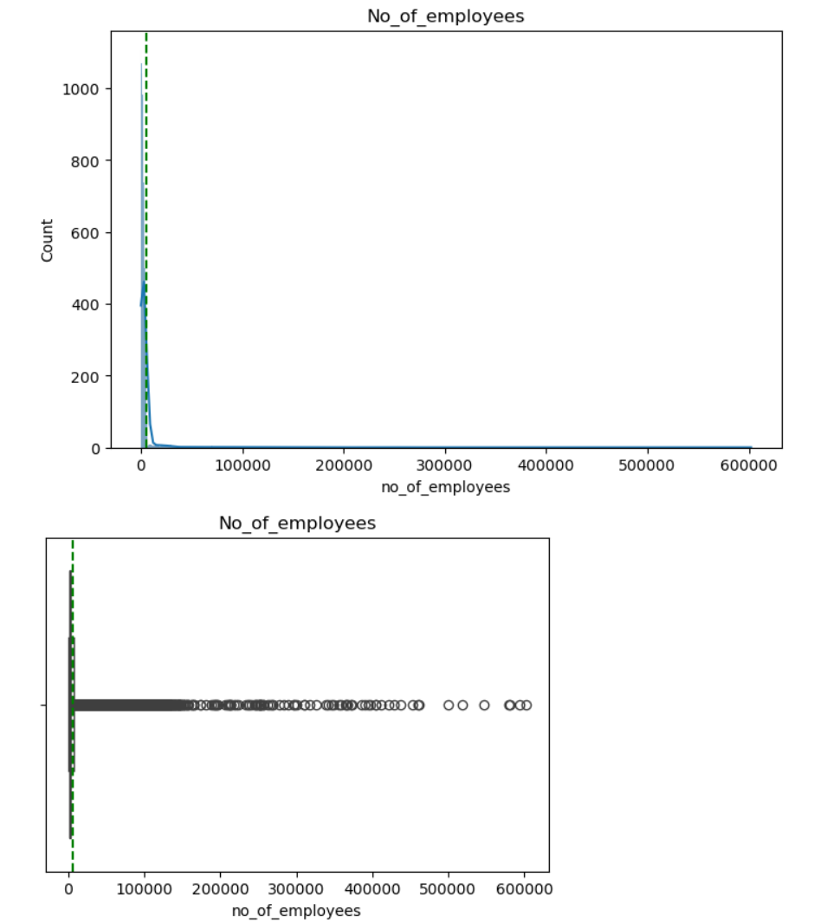

- Earlier we have seen negative data in number of employees column.
- After checking it we came to conclusion that those were caused by typing error and change them to positive number before building the plot.
- Now here we can see that distribution is highly right skewed with many outliers on the upper side.
- Most of companies have less than 10000 employees which suggests there are many medium to small size companies who are employing here.

Year of establishment Uni-Analysis :
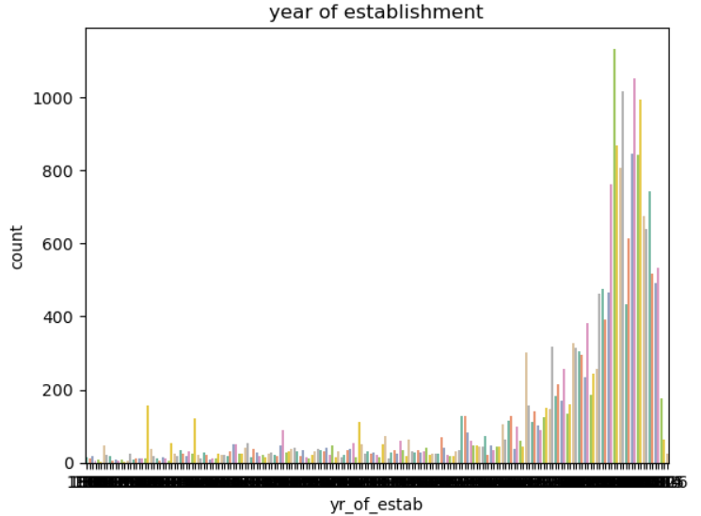
- This data doesn’t tell us Much, but by visuals here we can still tell that there very few old companies that are still hiring in large scale.

Region of employment Uni-Analysis :
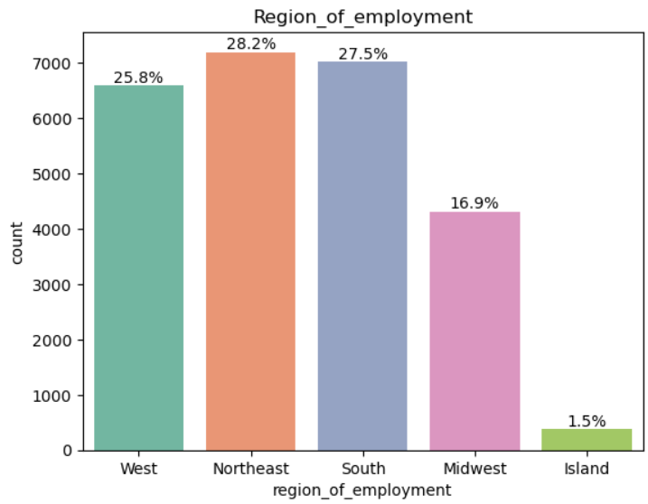

- Most worker request comes from Northeast(28.2%). Followed by South(27.5%) and West(25.85).
- Only about 1.5% request comes from Island region.

Prevailing wage Uni-Analysis :
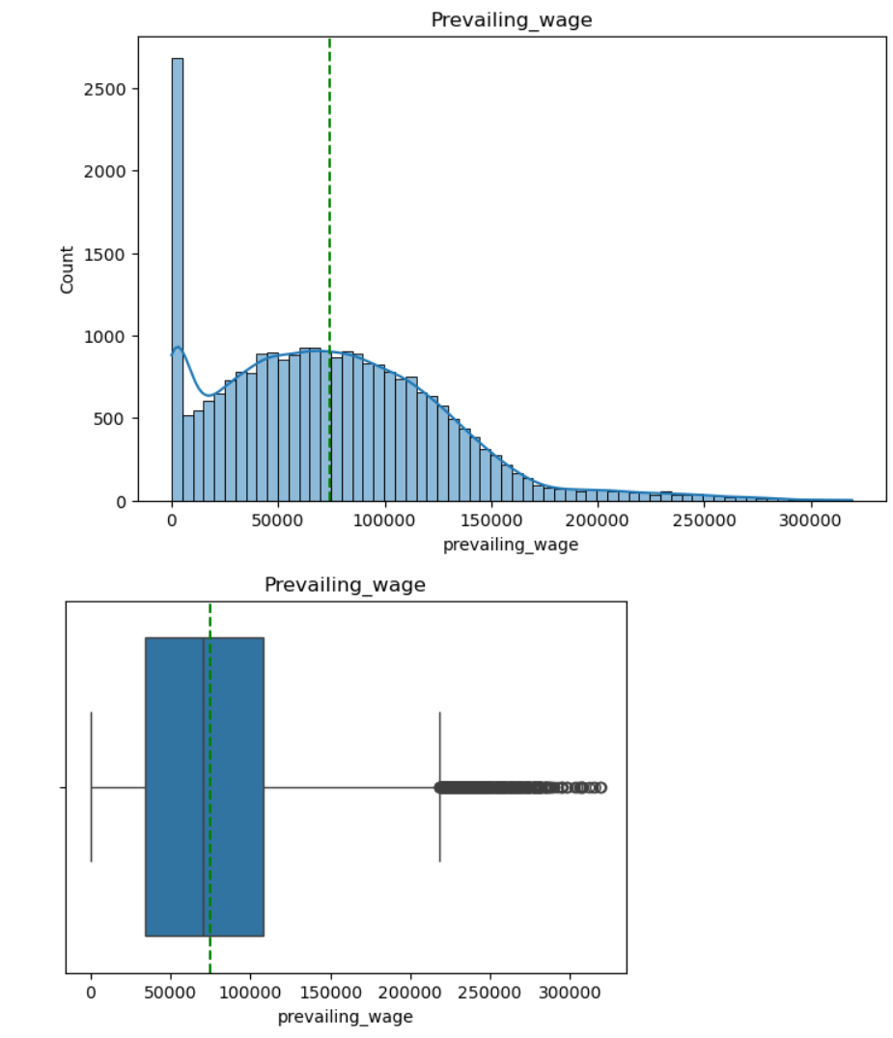

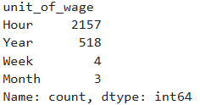
- Now in our previous analysis, we have seen that there’s huge variations in wages and we can see it’s because of unit of wages as most of them are hourly wages where wages are below 5000.
- The mean and median are around at 75000.
- There are many outliers on the upper side.

Unit of wages Uni-Analysis :
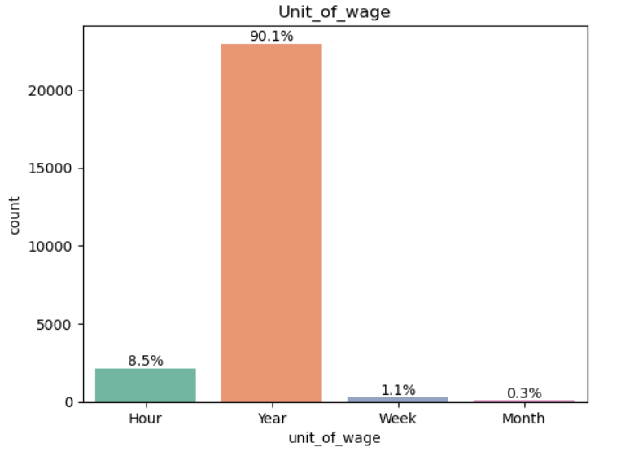

- Most of the wages are given yearly, which is about 90.1%.
- 8.5% of the wages are paid hourly.
- Very few wages are paid weekly or monthly.

Full time position Uni-Analysis :
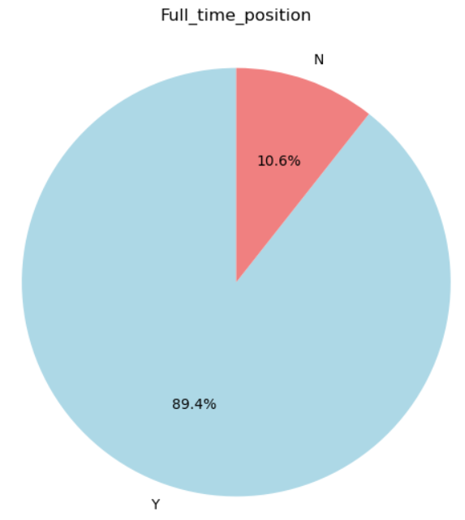
- 89.4% position offered by employers are full time.

Case Status Uni-Analysis :

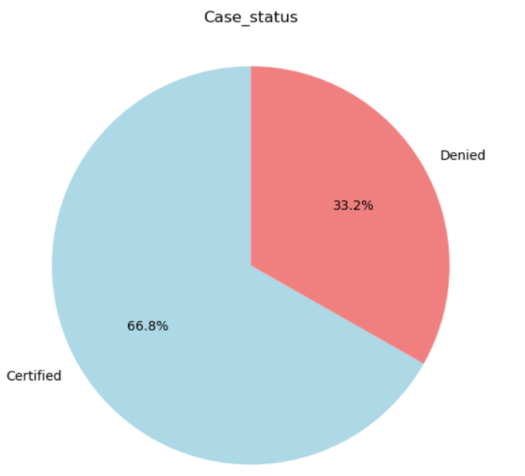

- Out of all the applications,66.8% of visa got approved.
Bivariate Analysis:
- Explore all the numerical variables and check their association with each
other.

Correlation heatmap of numerical variables:

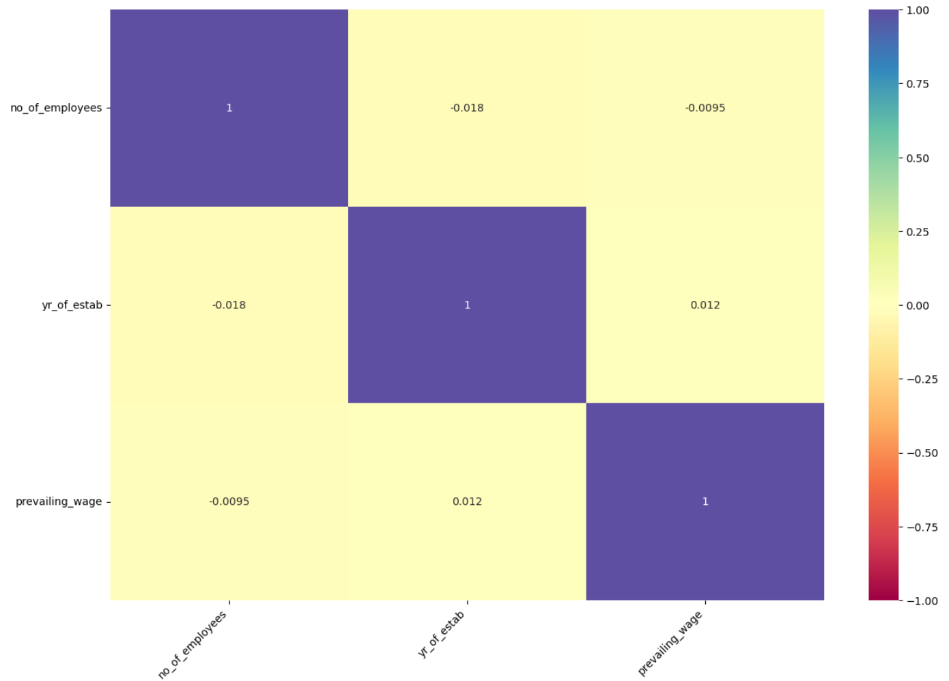
- There’s no significant correlation between variables as corelation coefficient between these variables are close to 0.

Bivariate Analysis on Education of employee and case status:
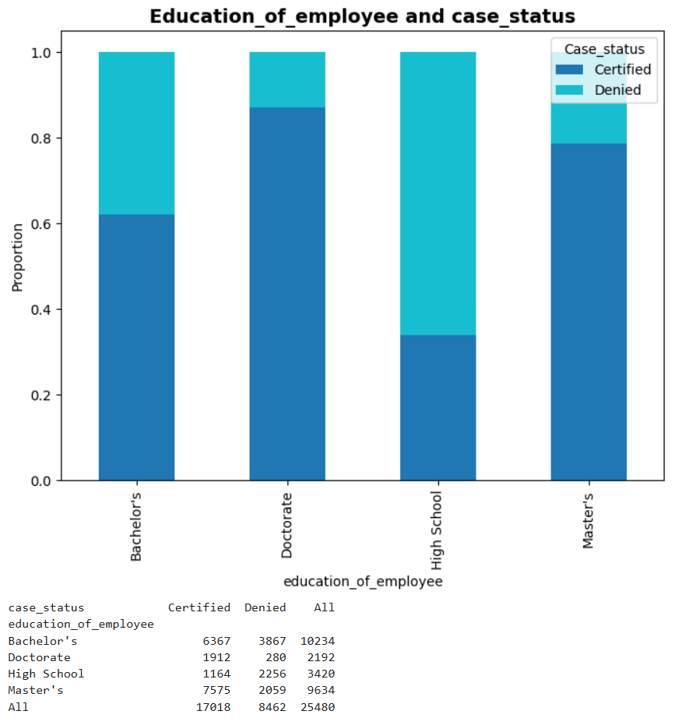
- The more education someone has, the better their chance of getting approved as doctorate candidates have highest approval.
- People with just a High School diploma have least chance of approval among all the other education type.
- Those with a bachelor’s degree or more have above 60% approval rate.

Bivariate Analysis on Continent and case status:

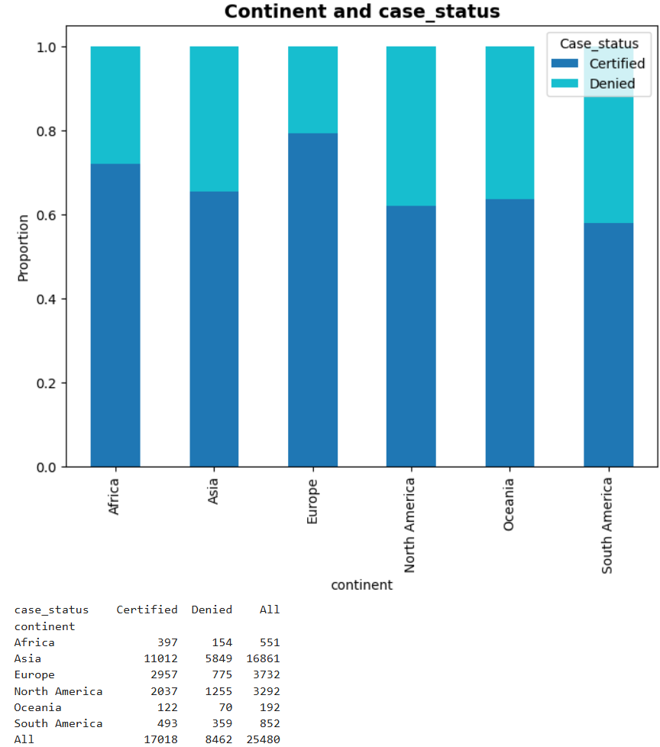
- Europe has highest approval rate with around 80%.
- South America has lowest approval rate, around 60%.

Bivariate Analysis on Job experience and case status:
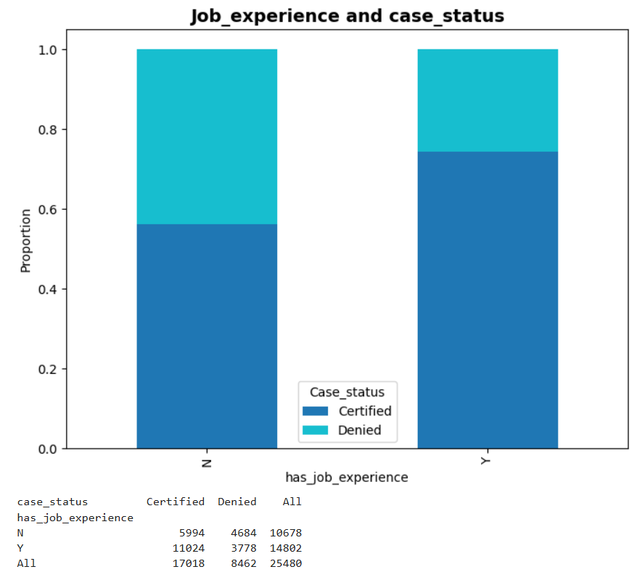

- People with job experience has more approval rate than people with no experience, around 75%.

Bivariate Analysis on Job training requirement and case status:

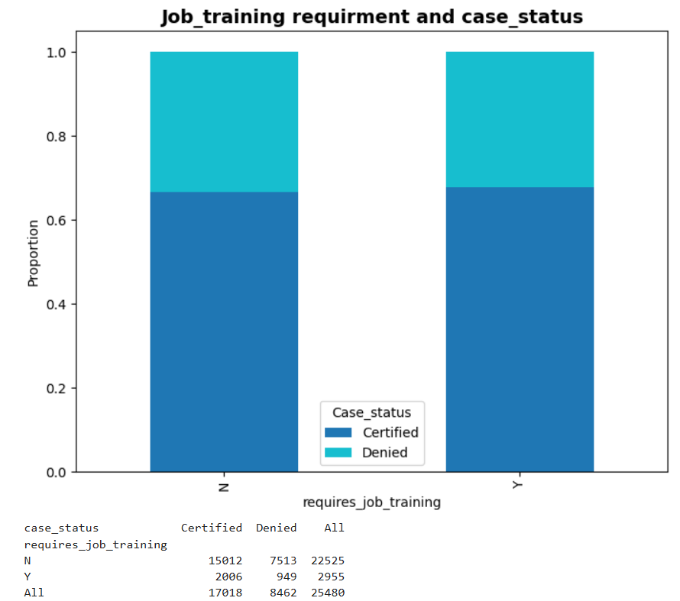
- The proportion of "Certified" and "Denied" cases is roughly similar between the two groups and job training does not significantly affect the case status outcome in terms of proportion.

Bivariate Analysis on Region of employment and case status:

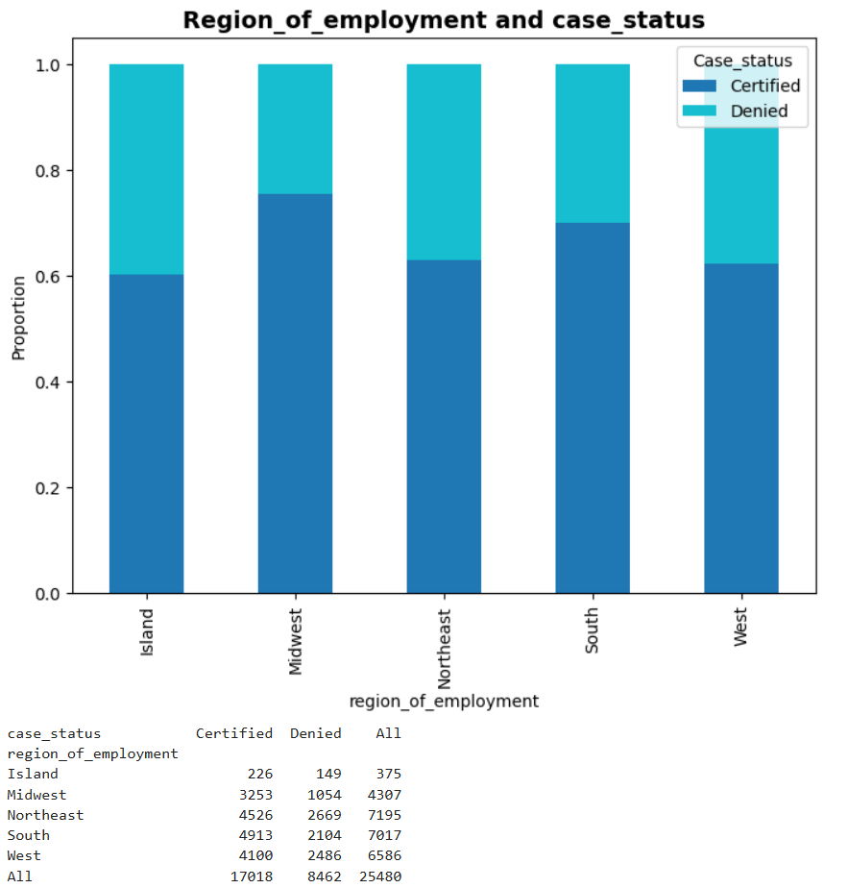

- Midwest and South have the highest certified rates at around 75% and 70%.
- Island have least number of applications with around 60% certified rate.

Bivariate Analysis on Unit of wage and case status:
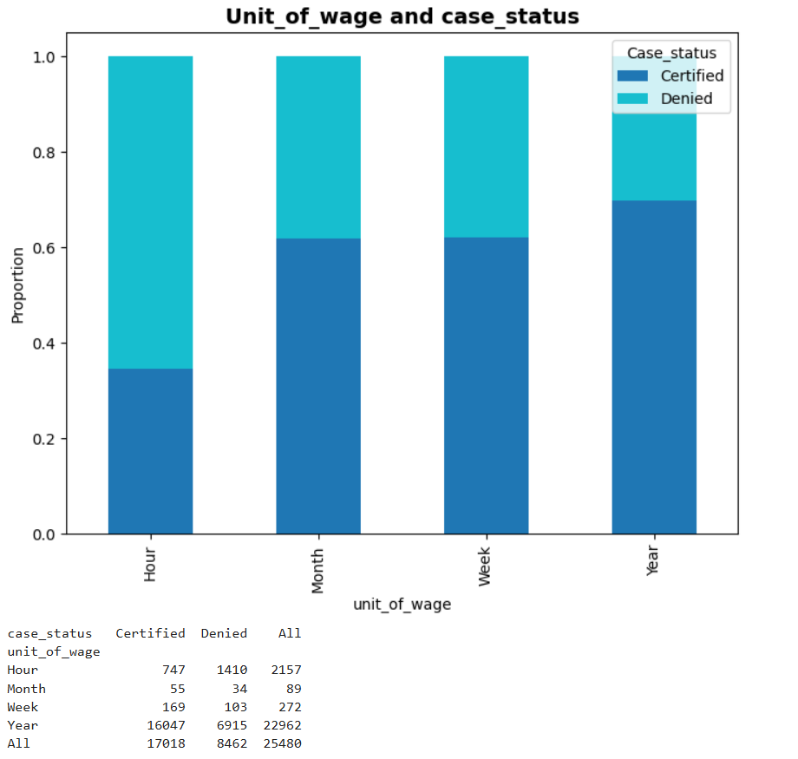

- People who earn hourly wages have least approval rate, around 30%.
- Yearly wages have highest approval rate among all of unit of wages, around 70%.

Bivariate Analysis on Prevailing wage and case status:

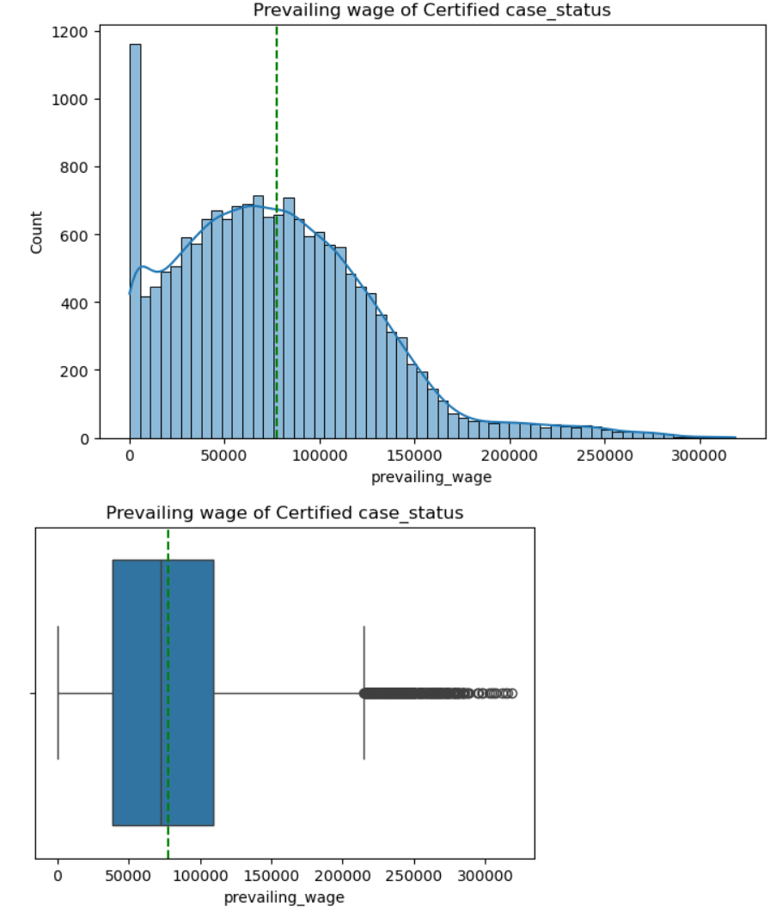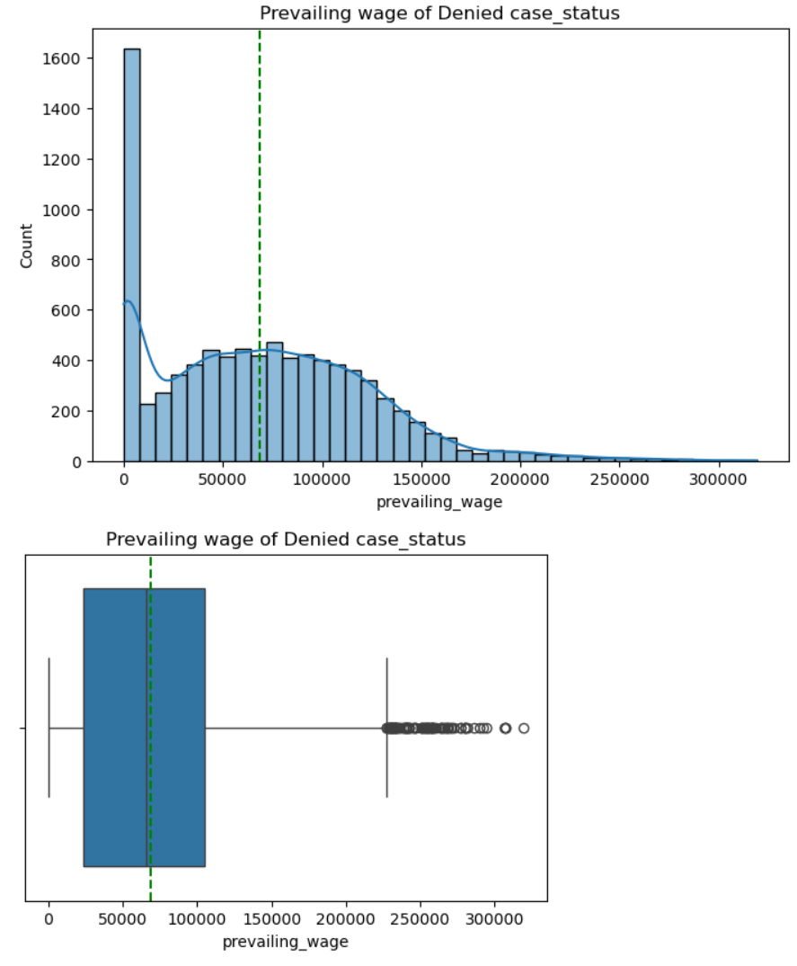

- The median wage for certified applications is a bit higher than for denied ones.
- But the prevailing wage is the same in certified and denied case status.

Bivariate Analysis on Prevailing wage and Education of employee:

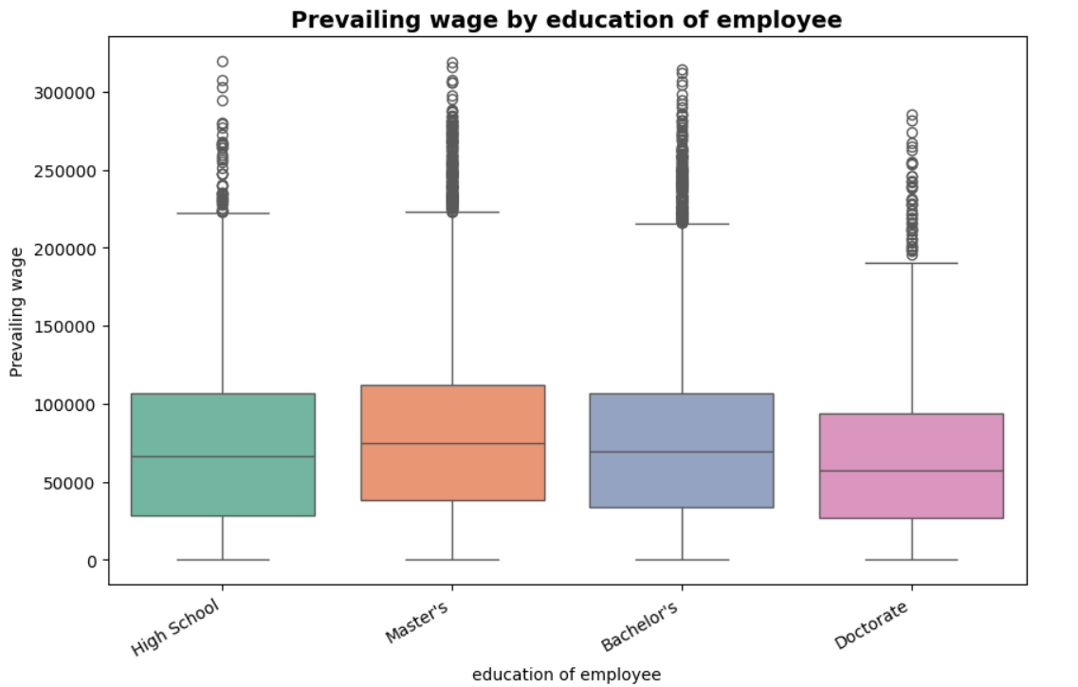
- People with master’s have highest median wages, followed by people with bachelor’s degree.
- Surprisingly, people with doctoral degrees have lowest median wages.

Bivariate Analysis on Prevailing wage and region of employment:

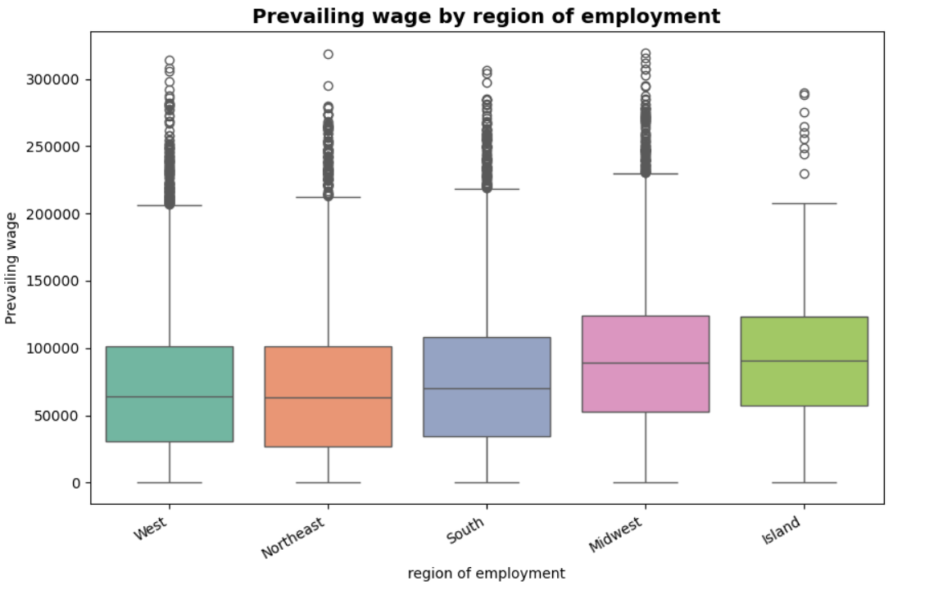

- Even though Island have least number of applications among the regions, it has highest median wages, followed by Midwest.

Bivariate Analysis on Prevailing wage and Job experience:
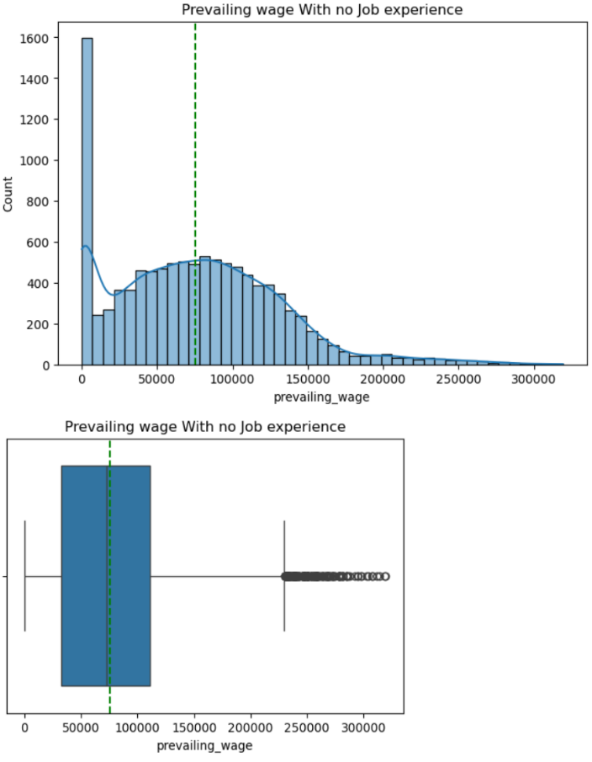
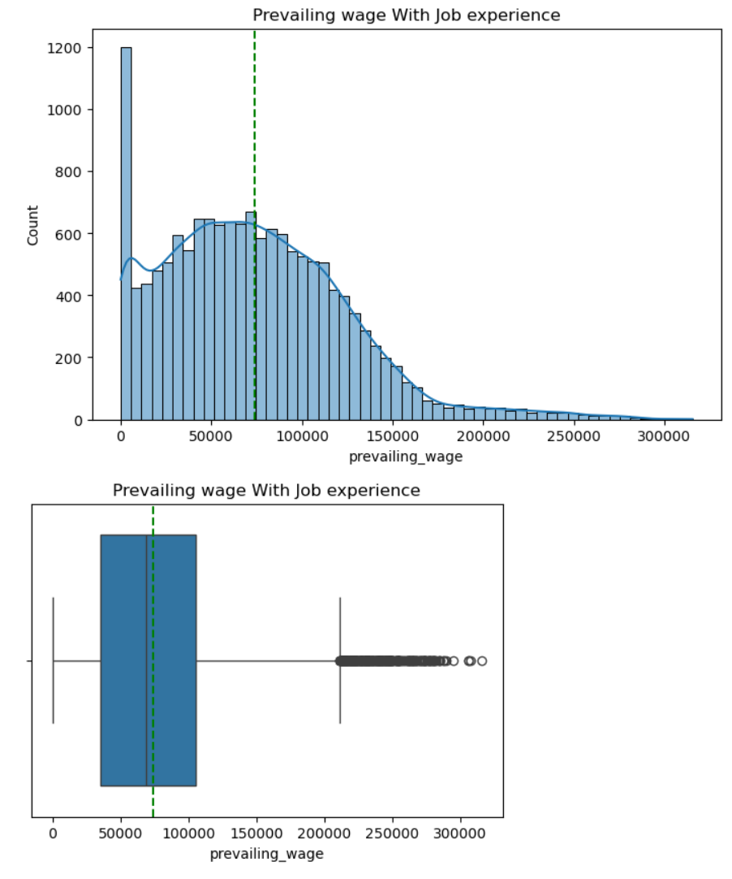
- There’s not much difference in prevailing wage for with Job experience or without job experience.
- But in both cases, there are many outliers on the upper side.

Bivariate Analysis on Prevailing wage and Job Training Required:
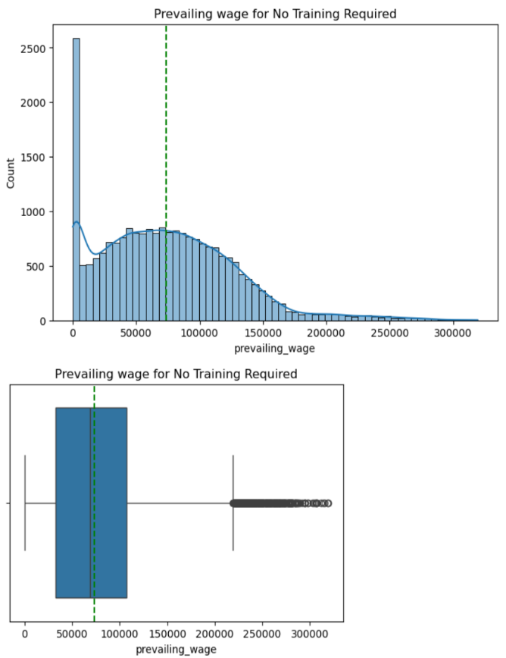
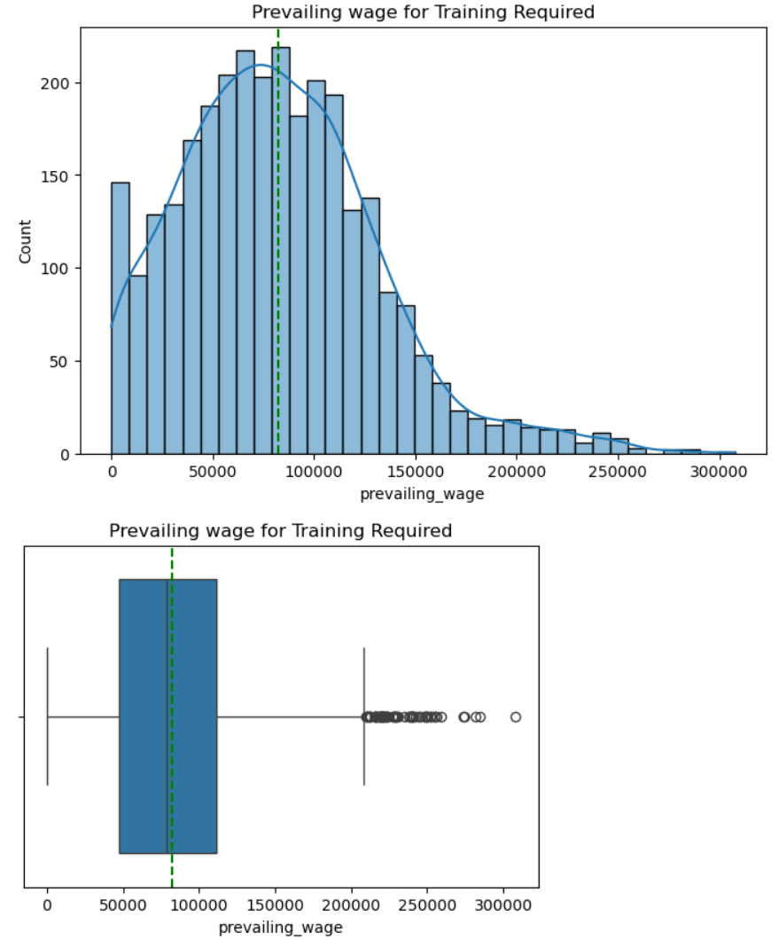

- The median wage for trained applicants is a bit higher than the applicants who requires training.
- The distribution is right skewed and have many outliers in the data.

Bivariate Analysis on Prevailing wage and Education of employee based on Job experience :

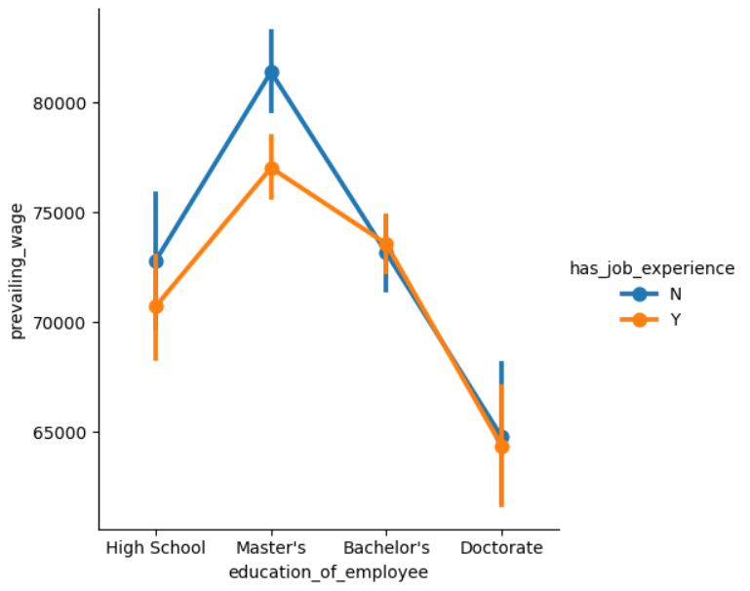
- Surprisingly, People no experience and with master’s degree have highest wages.
- People with Doctorate have the lowest wages, whether they have experience or not.

7. Data Pre-processing:
Outlier detection and treatment-

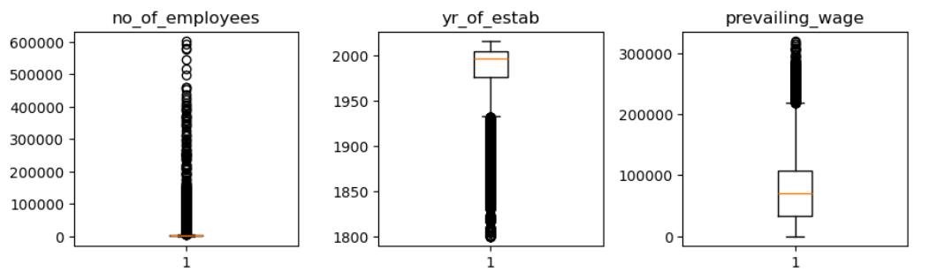
- We have decided to keep the outliers as they might have valuable inputs.

Missing value treatment-
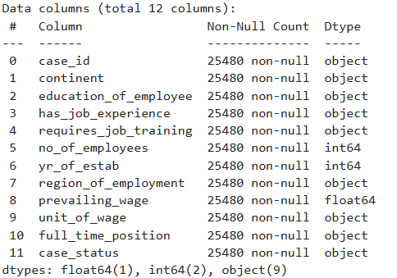

- No missing value were found in the dataset.

Feature engineering:
- Column 'case_id' has already been dropped.
- Target variable (case_status) is of categorical type, we will change this to a binary variable (0,1).

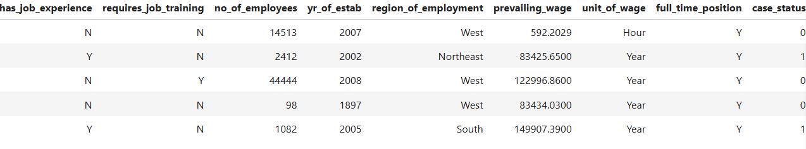
Model Building:

Data preparation for model:
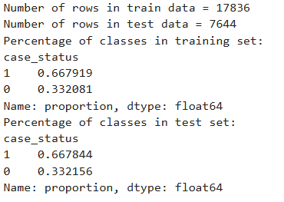

Model evaluation criterion:

Model can make wrong predictions as:
- Model predicted a visa to be denied but, the visa was certified.
- Model predicted a visa to be certified but, it was denied.

Choosing the appropriate metric for model evaluation:
- The F1-score balances precision (correctly approving eligible applicants) and recall (capturing all eligible applicants). It’s ideal for imbalanced datasets, which are common in visa approval scenarios (e.g., more approvals than denials or vice versa).
- We'll use GridSearchCv and RandomSearch CV for hyperparameter tuning and F1 score to optimize the model.
- We will maximize F1 score by building different models. The greater the F1-Score higher the chances of predicting both the classes correctly.

Decision Tree Model building and hyperparameter tuning-Original data:

Checking Performance on the Training set with default threshold(0.5 )-

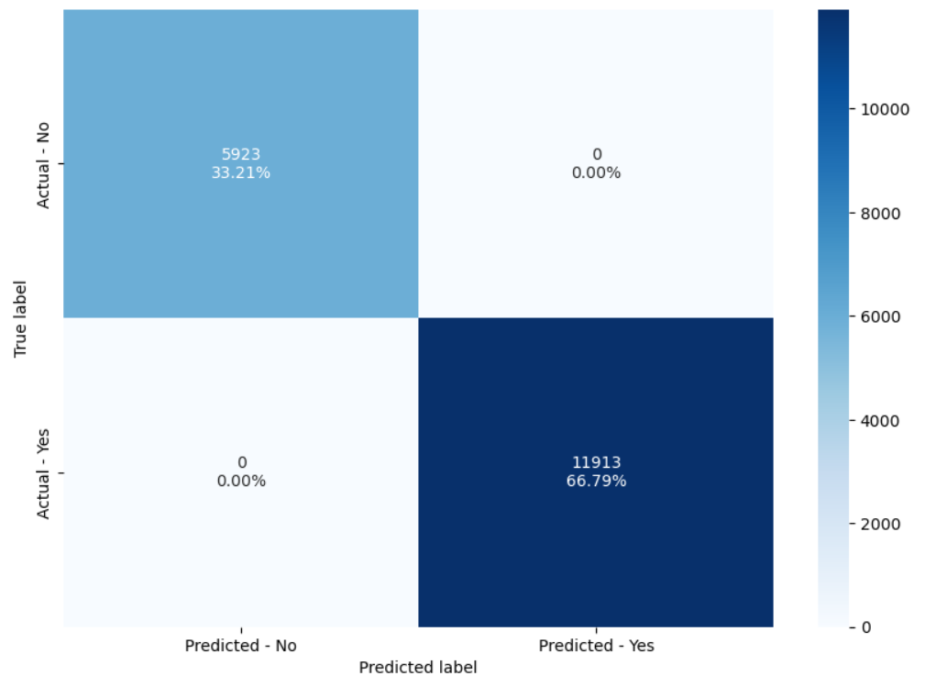
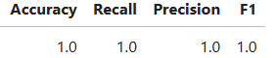
- The top left quadrant shows True Negative values. In this case, the model correctly predicted 33.21% of the visas to be denied.
- The top right quadrant shows False Positive values.
- The model predicted a visa to be approved when it was denied. The model is overfitting because it split completely and correctly predicted no visas were incorrectly classified here.
- The bottom left quadrant is False Negatives.
- The model predicts a visa to be denied but it was approved.
- On the bottom right corner is True Positives.
- Our model correctly classifies the approved visas, which is 66.79% of the total or 11,913.

Checking Performance on the Test set with default threshold(0.5 )-
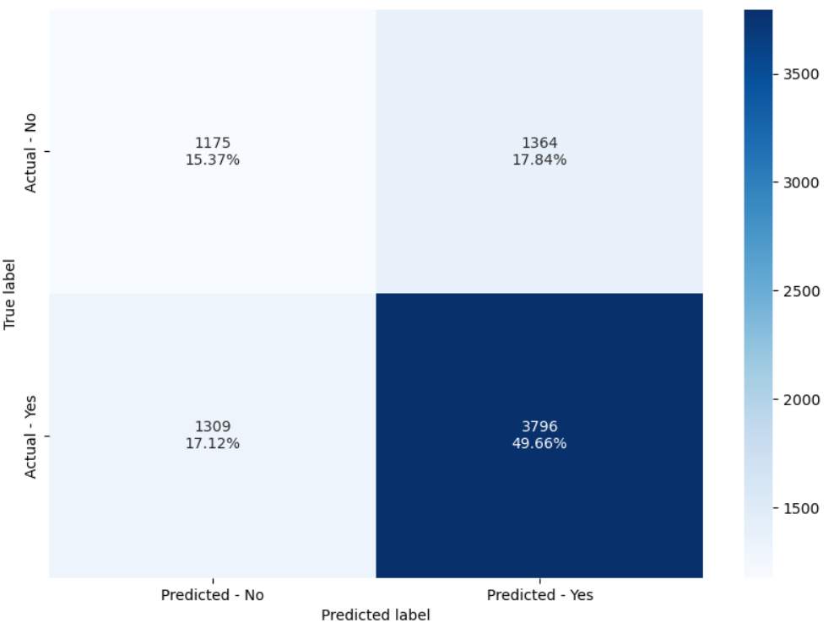

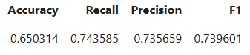

- The model is clearly overfitting in the training set as model is performing poorly in test set.
- It suggests that model has failed to generalize in test data.

GS Tuned decision tree performance on training set-

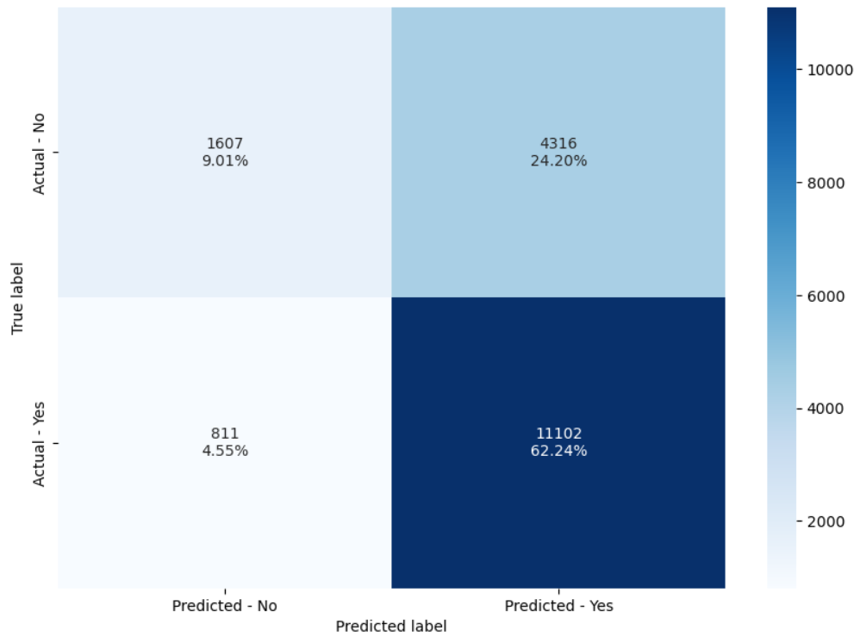

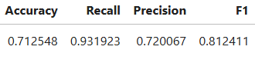

GS Tuned decision tree performance on test set-

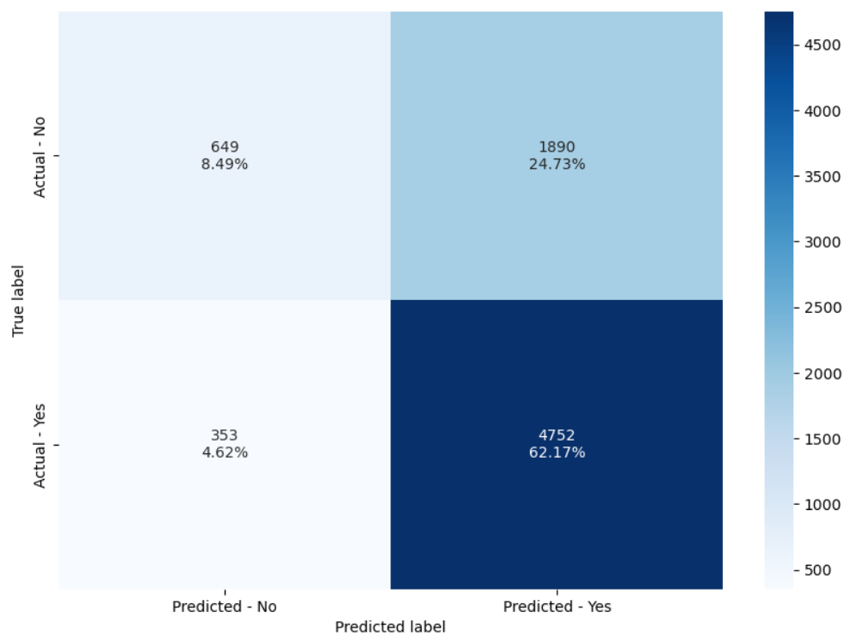
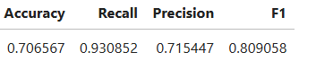
- Test F1 score has increased from previous model.
- Model is able to generalize well now as F1 score is close to 81 for both train and test data set.

Bagging Model building and hyperparameter tuning-Original data:

Checking Performance on the Training set with default threshold(0.5 )-
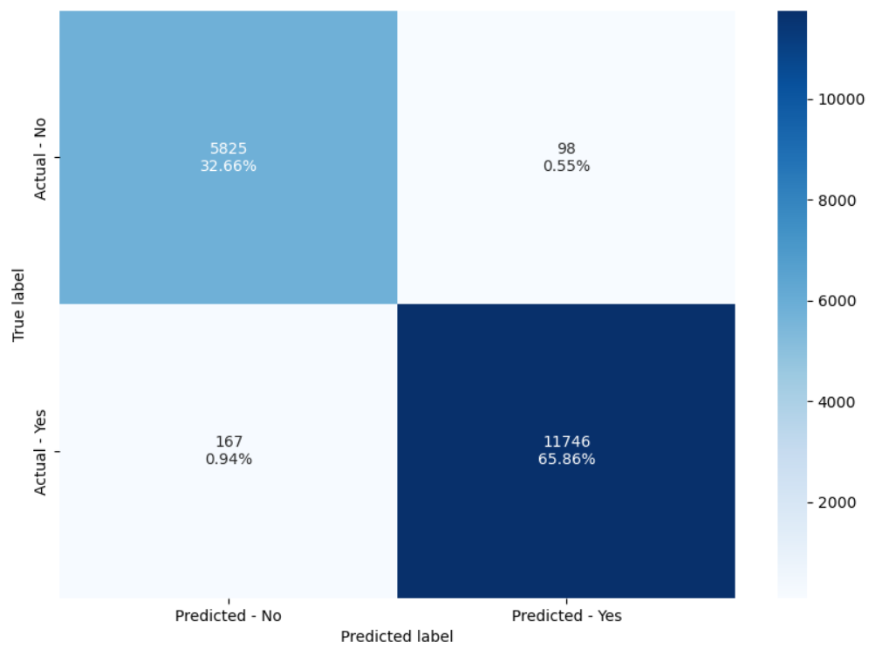
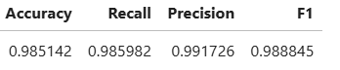

Checking Performance on the Test set with default threshold(0.5 )-

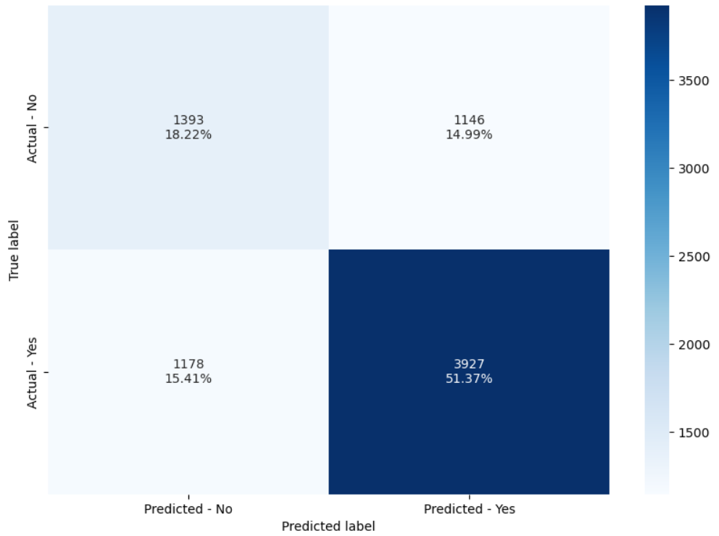
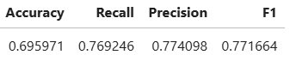

- The Bagging model is also overfitting in the training set as model is performing very well in Training but poorly in test set.

GS Tuned Bagging classifier performance on training set-
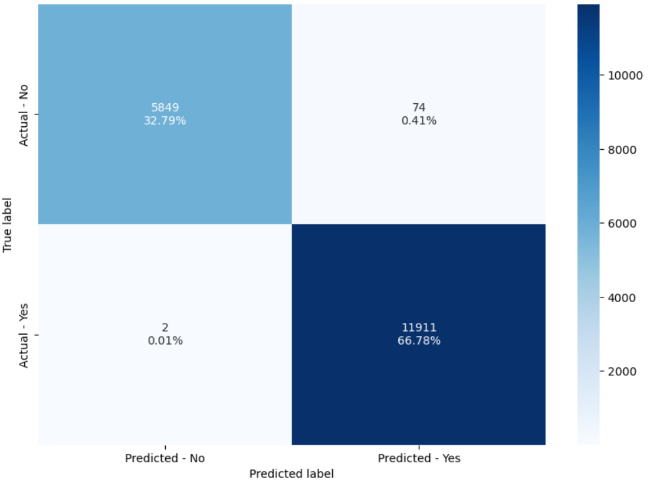
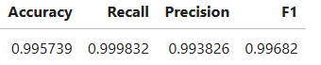

GS Tuned Bagging classifier performance on training set-

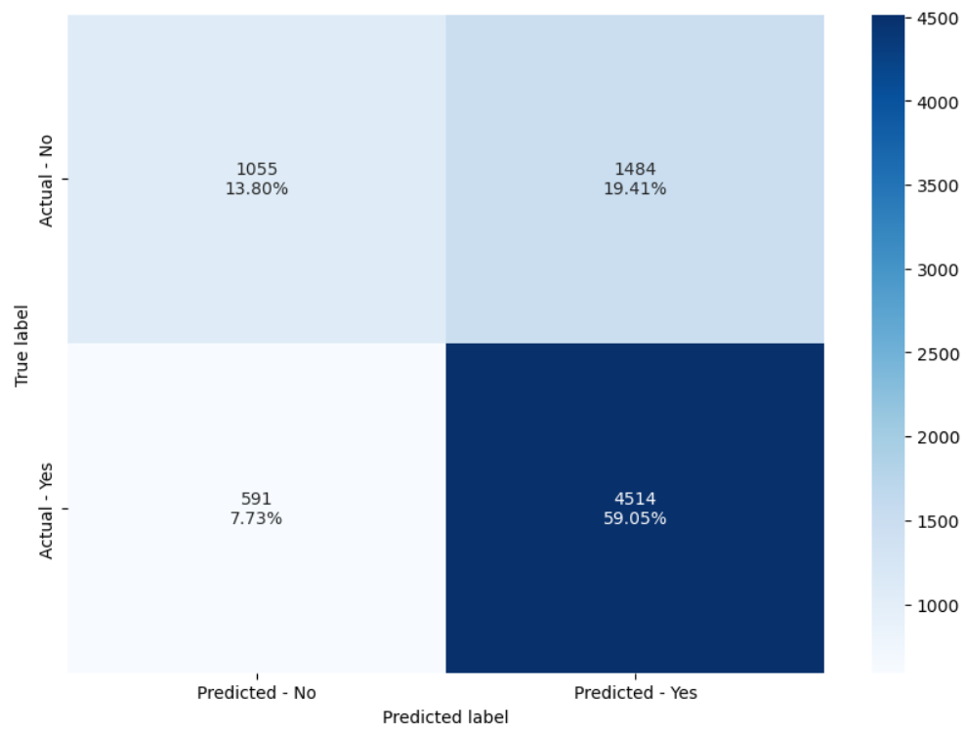
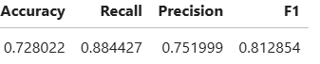

- F1 Score and other metrics have improved in test data.
- But model is still overfitting as there’s big gap in metrics of training and test data.

Random Forest Model building and hyperparameter tuning-Original data:

Checking Performance on the Training set with default threshold(0.5 )-

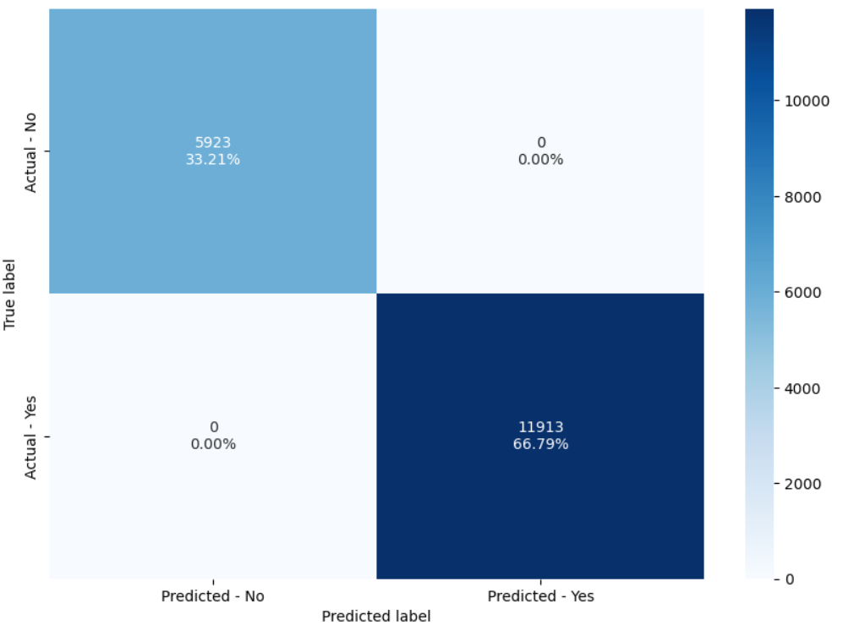

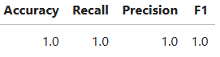

Checking Performance on the Test set with default threshold(0.5 )-

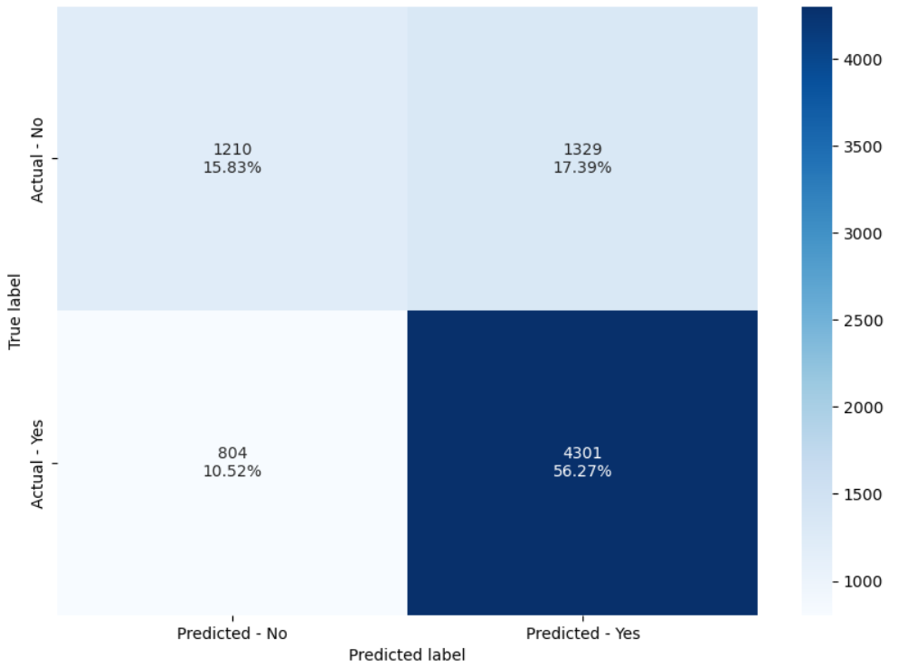

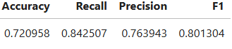

- Test f1 score has not improved much as compared to previous models.
- Random forest is overfitting the training data as there is a huge difference between training and test scores for all the metrics.

GS Tuned Random Forest classifier performance on training set-

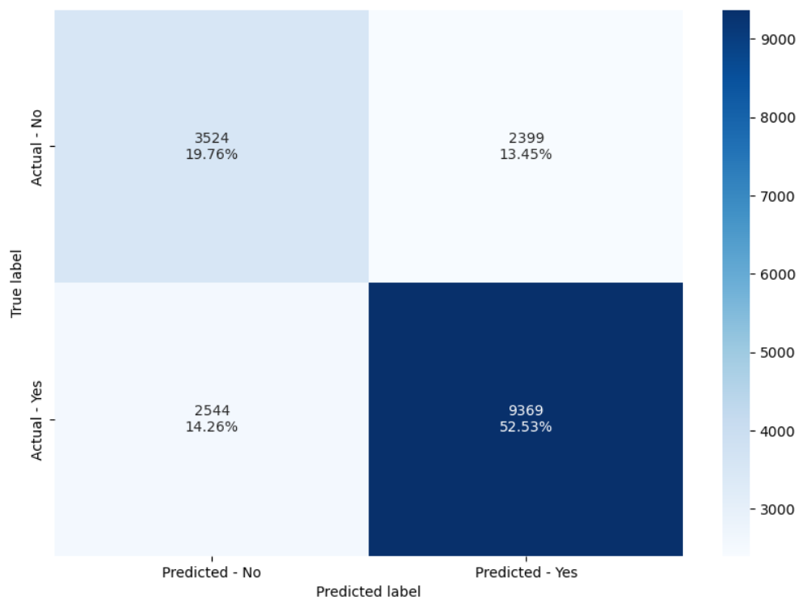

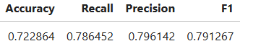

GS Tuned Random Forest classifier performance on test set-

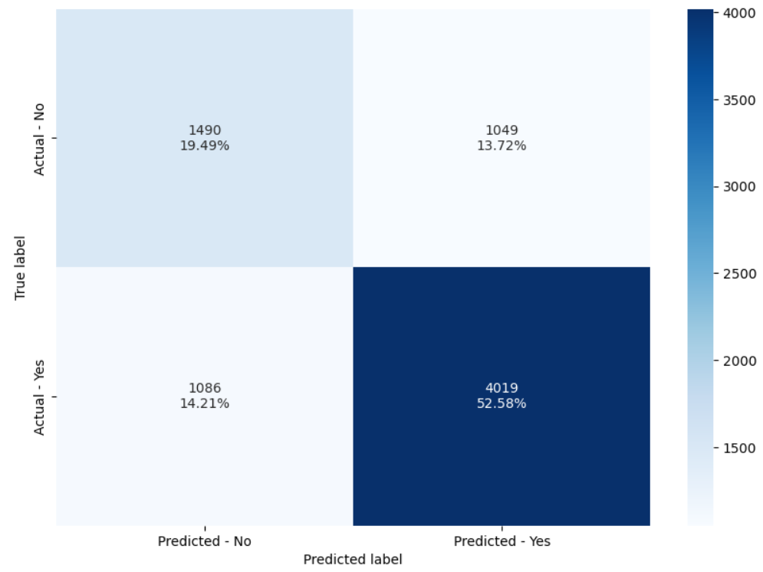

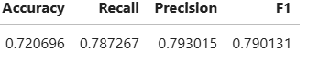

- Model is performing well in both Training and test data, both F1 scores are around 79.

Boosting Model building and hyperparameter tuning-Original data:

AdaBoost Classifier-

Checking Performance on the Training set with default threshold(0.5 )-

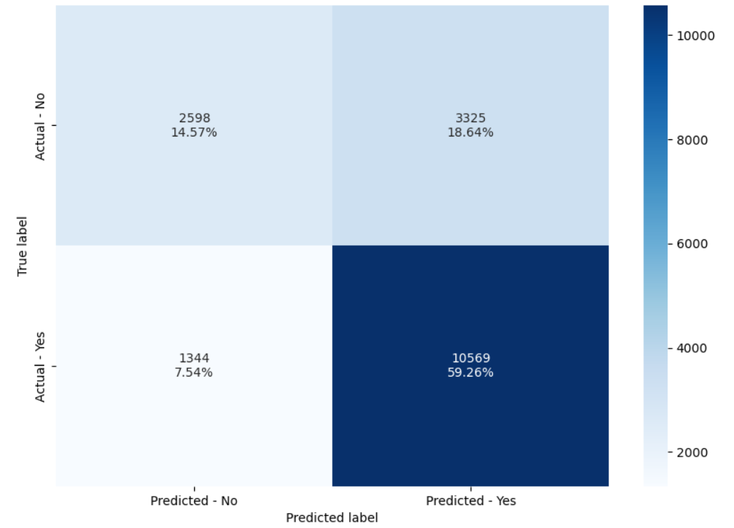

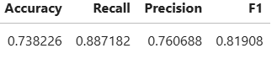

Checking Performance on the Test set with default threshold(0.5 )-

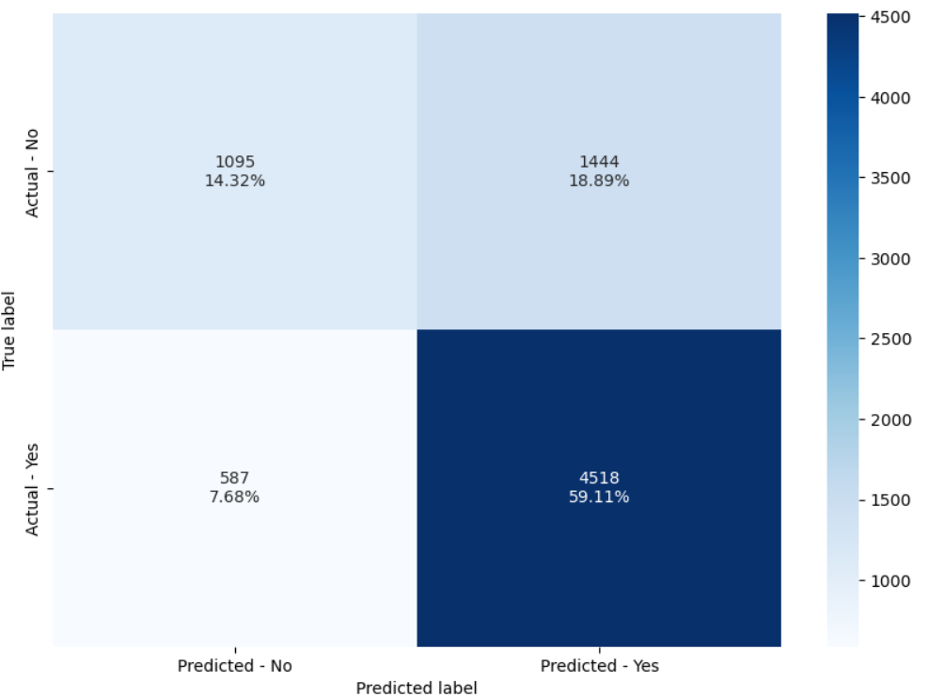

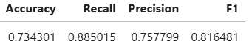

- All the metrics are very close to each other for training and test data set, that means model have been able to generalize well.

GS Tuned AdaBoost performance on training set-

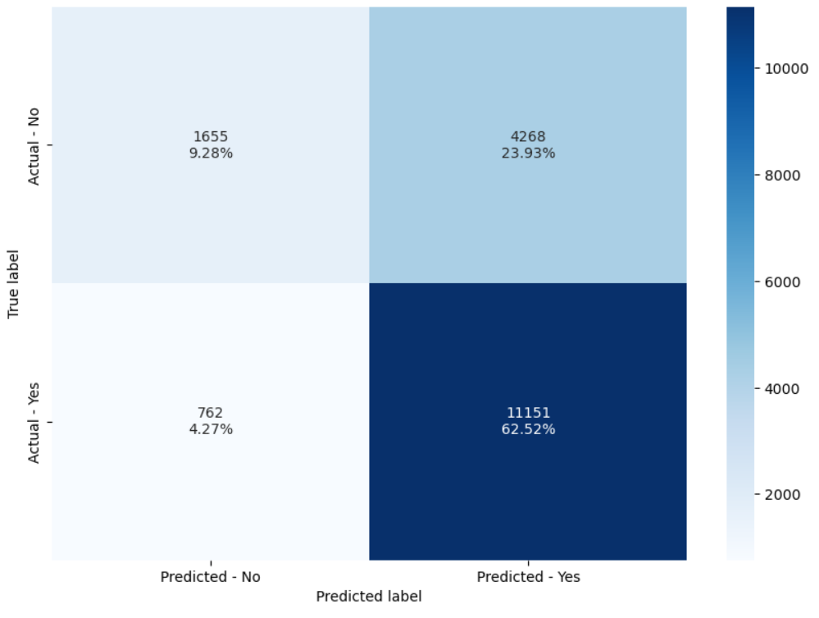

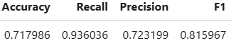

GS Tuned AdaBoost performance on test set-

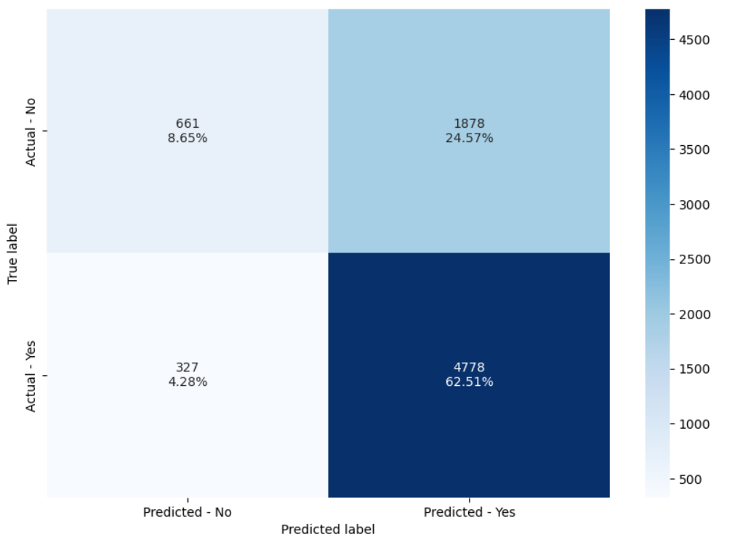

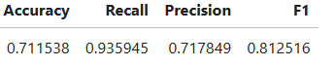

- Tuned Adaboost performing slightly better on recall in test data.
- But there no huge difference in overall performance from default Adaboost.

Gradient boost Classifier-

Checking Performance on the Training set with default threshold(0.5 )-

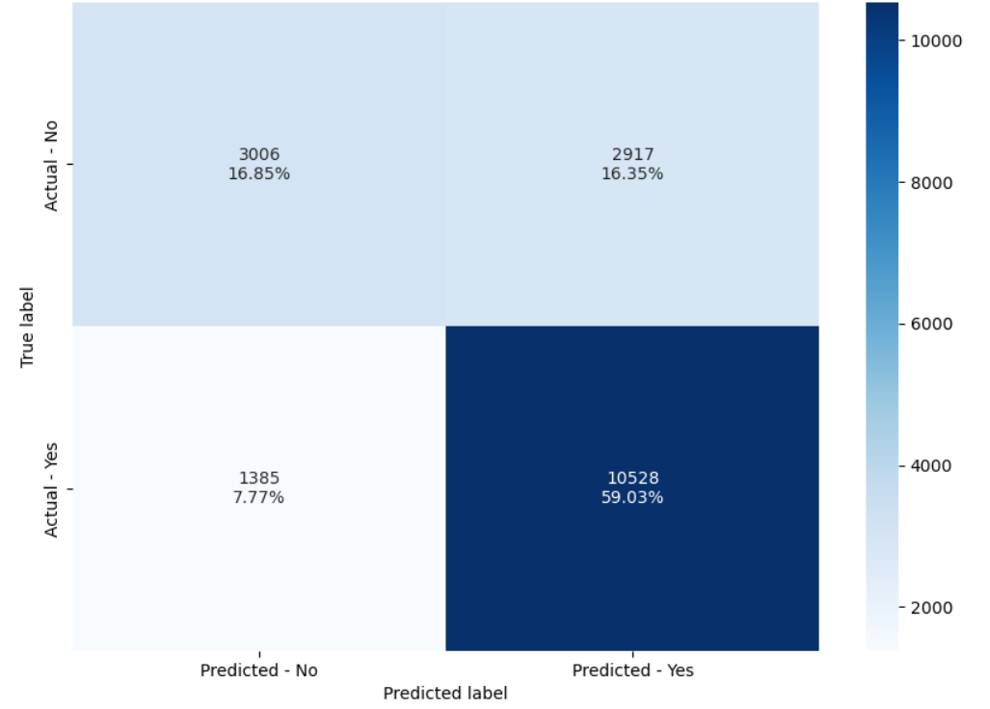

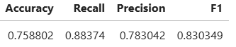

Checking Performance on the Test set with default threshold(0.5 )-

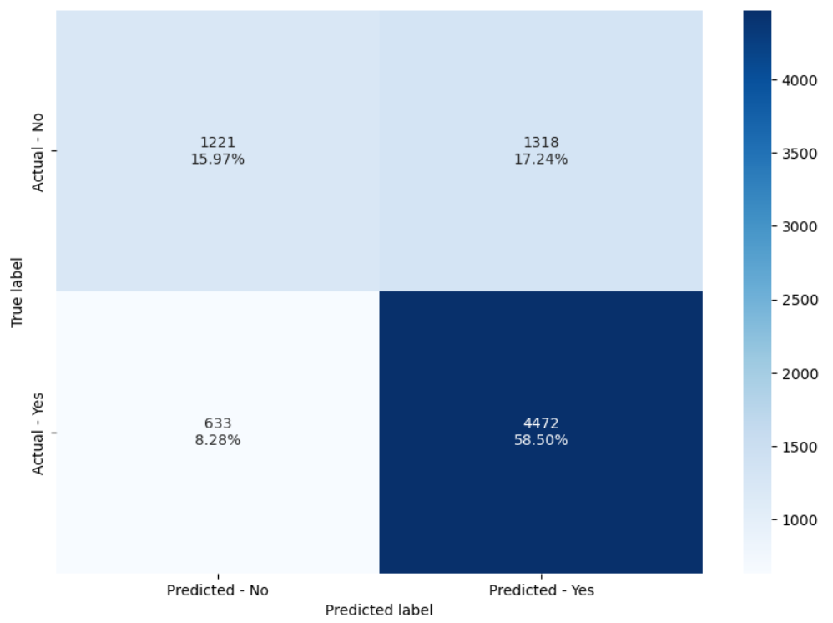

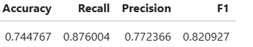

- Gradient boost classifier working well on both training and test data and not overfitting the model.

GS Tuned Gradient Boost performance on training set-

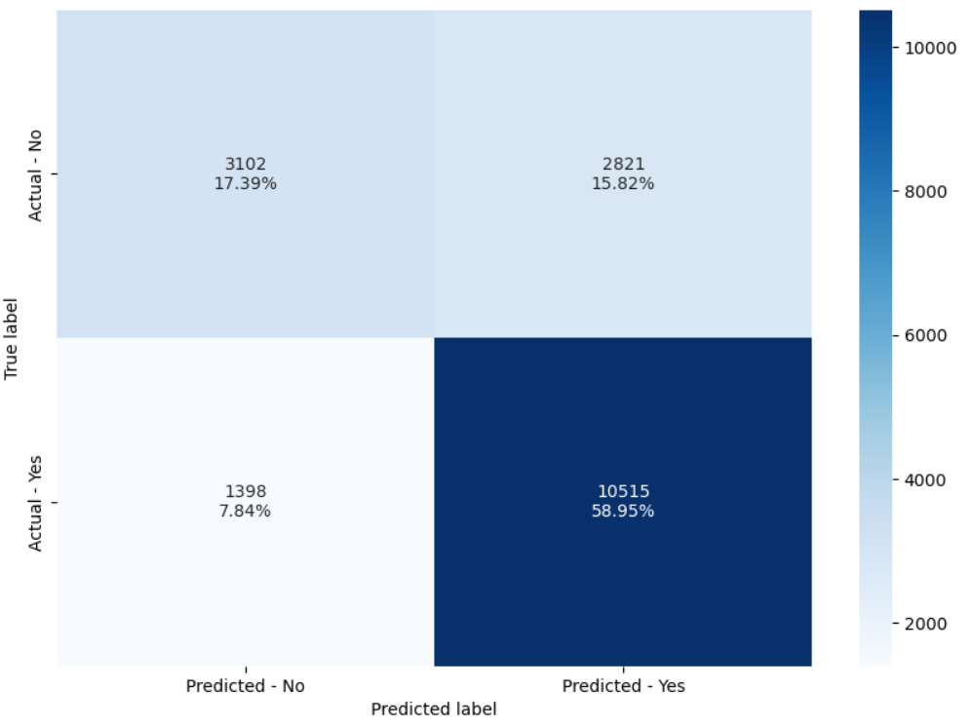

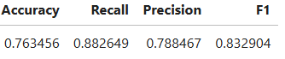

GS Tuned Gradient Boost performance on test set-

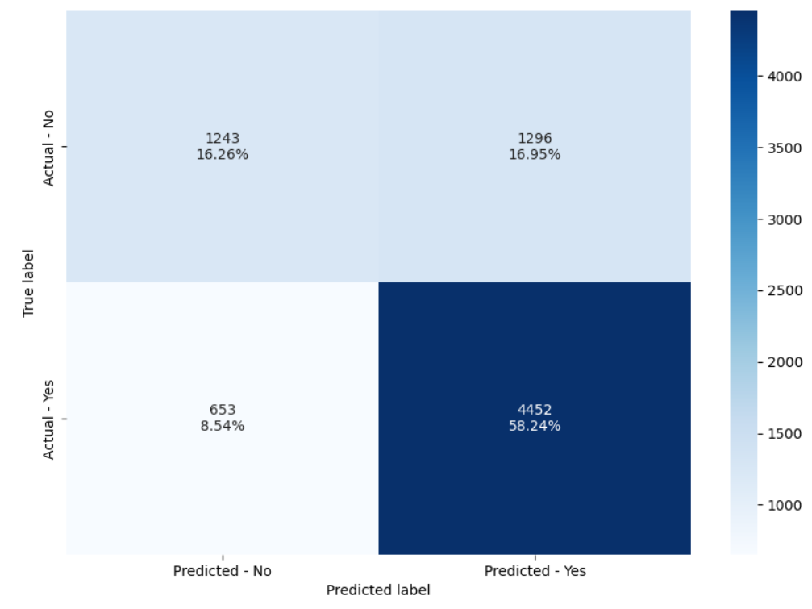

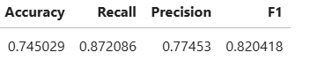

- The tuned version is generalizing well in the test data, but there is not much difference between the default and the tuned version.

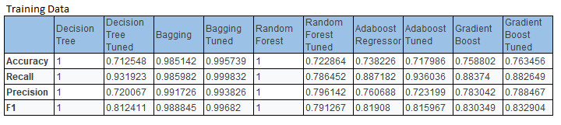
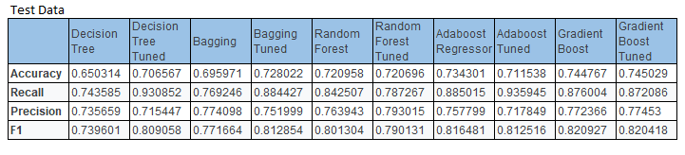

- Random Forest and AdaBoost tuned models are generalizing well but Accuracy and precision is low.
- Decision tree, bagging and random forest are overfitting the training data.
- Among all the models, based on all the metrics of train and test set, the best performing model is the Gradient boost Tuned model.

